**CODE:**

void setup()

{

Serial.begin(12400);

pinMode(3,INPUT);

pinMode(2,OUTPUT);

}

void loop()

{

int freq1=1000,freq2=5000;

int n=digitalRead(3);

Serial.print("motion");

Serial.println(n);

delay(1000);

double temp=analogRead(A1);

double n1=temp/1024;

double vout=n1*5;

double off=vout-0.5;

double temperature=off*100;

Serial.println(temperature);

if(temperature>=60)

{

tone(2,freq2,1000);

}

else if(n==1)

{

tone(2,freq1,1000);

}

}

**SIMULATION:**

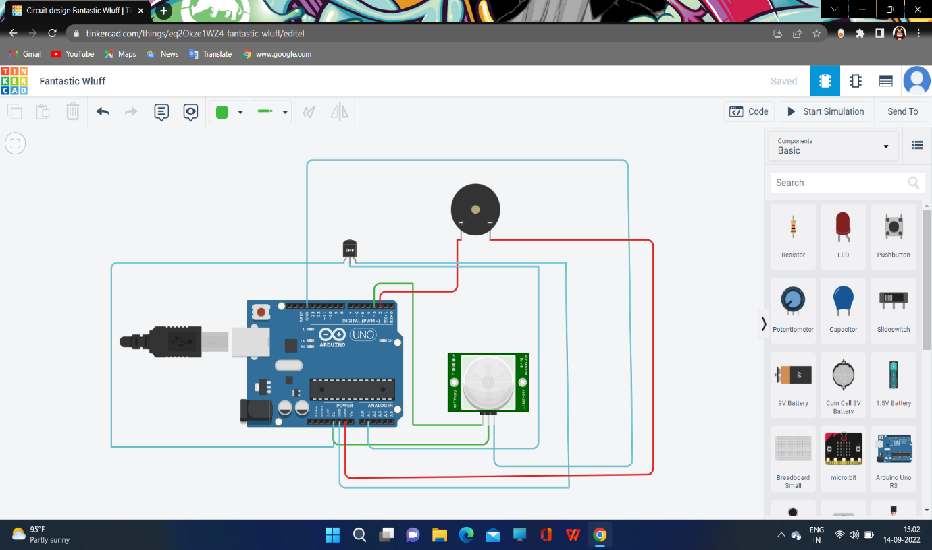

**OUTPUT:**

